**Instructions**:

* Upload the files to google colab under Colab Notebooks
* Run the py file
* For first time it will ask to authorize to google drive. Follow the link to get the authorization code and enter
* Default nodes are i.e. Harsha house: a, Pharmacy1: h and Pharmacy2: j
* Code will execute and save OutputPS8.txt to file to Google drive under Colab Notebooks.
* Execution time for the code once google drive authorized is 0.006728649139404297

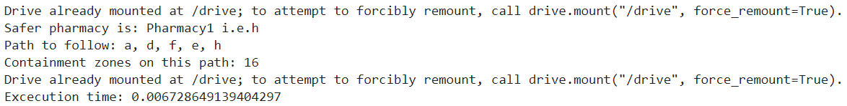

In case you want to enter the nodes dynamically please uncomment the block line#115 – 143.

* When you run it will ask to enter the node for Harsha’s house, Pharmacy1 and 2
* If no value entered it will take default i.e. Harsha house: a, Pharmacy1: h and Pharmacy2: j

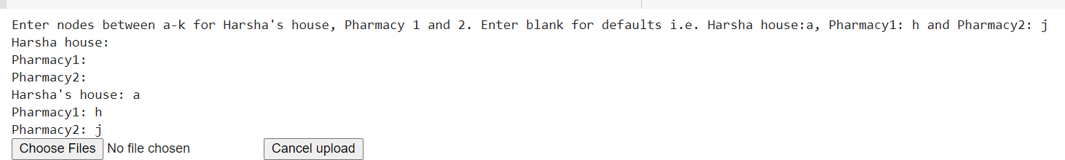

Result:

